About Project

- To run the website go to anaconda prompt admin type the fish dataset path ex.cd C:\Users\HP\Desktop\fish_dataset
- then type python app.py
- after it run go to the browser and type this url (http://127.0.0.1:5000) website will automatically run

- "My model achieves 94% training accuracy and 79% validation accuracy. Some misclassifications occur due to limited dataset size. when i add fish image sometime it shows wrong result bcz the train dataset is not enough. I added only 250 image for each classes . if I add 500-750 image it may train more…

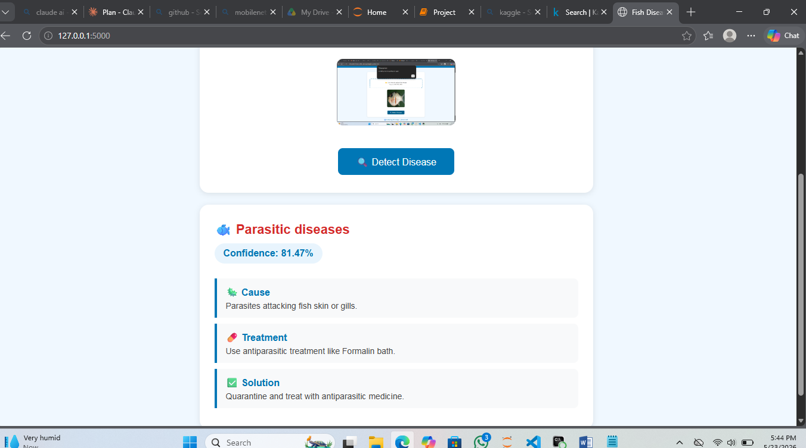

IT is a Bacterial Red disease but the output is different

It they ask about other algorithms you tried:
"I first tried a basic CNN model which gave 56% accuracy. Then I added data augmentation which improved to 83%. Finally I used MobileNetV2 with Transfer Learning which gave the best result of 95% training accuracy."

